SECTION 0

1. Create a directory ‘project_dir’ and cd to ‘project_dir’.

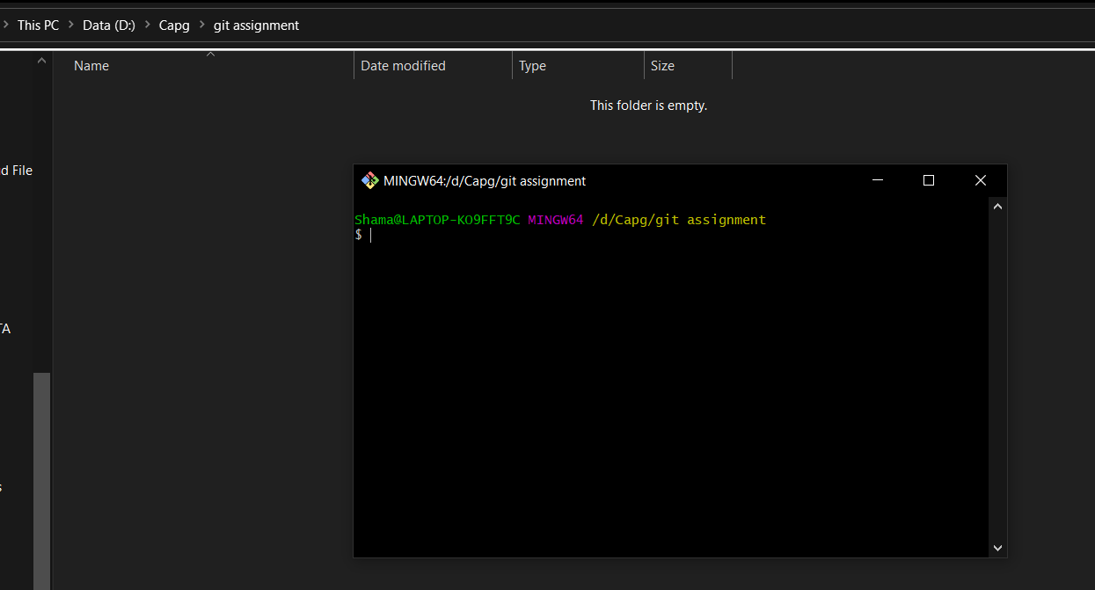

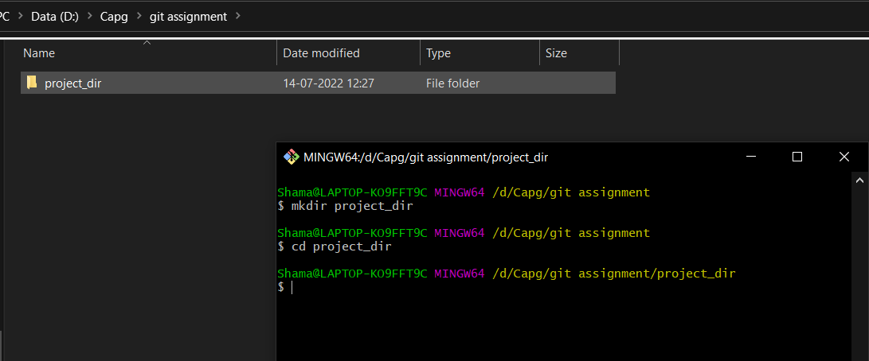

2. Initialised git version database.

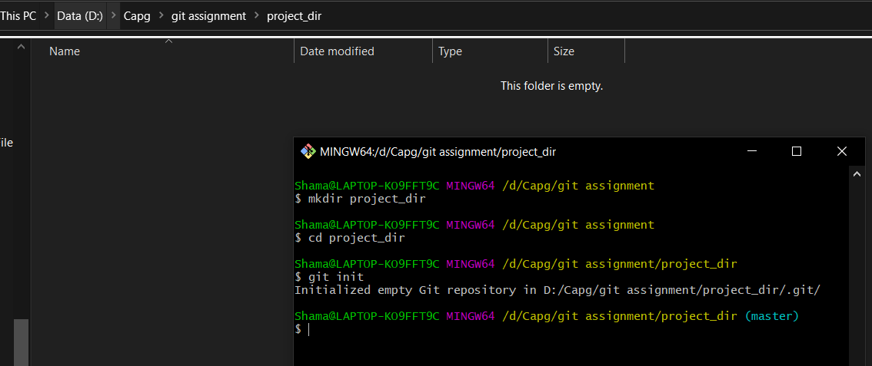

3. Create index.html file.

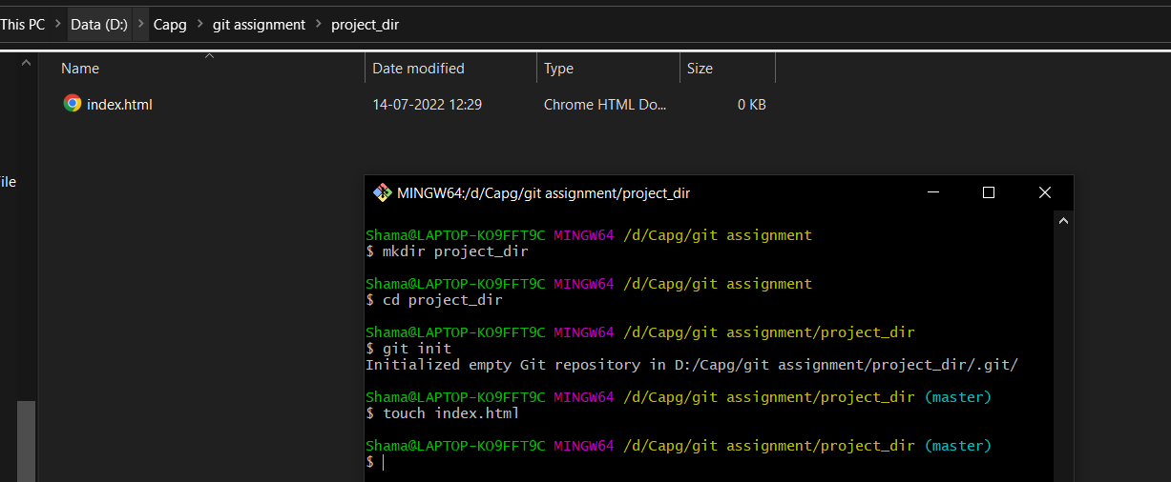

4. Check git status you should find index.html as untracked file .

5. Stage the index.html file.

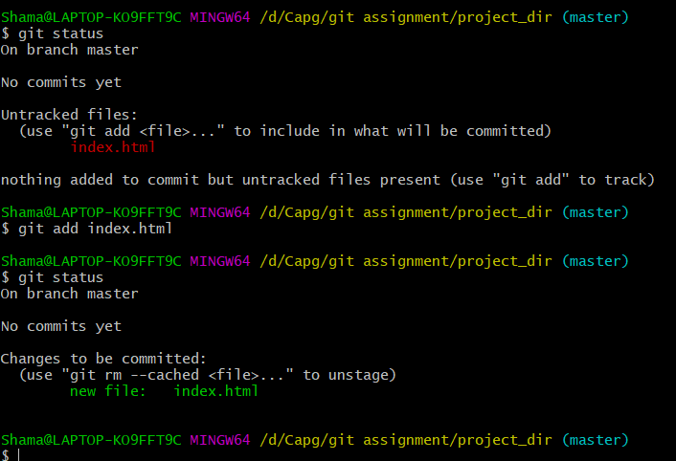

6. Commit index.html.

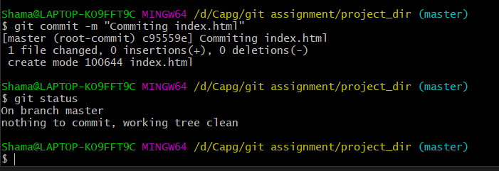

7. Make few changes in index.html & create new file info.txt.

8. Check status. You should find index.html & info.txt as untracked files.

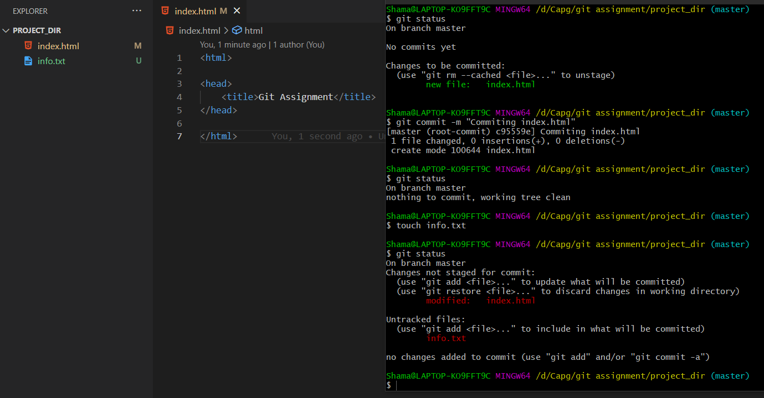

9. Configure GIT to ignore all txt files.

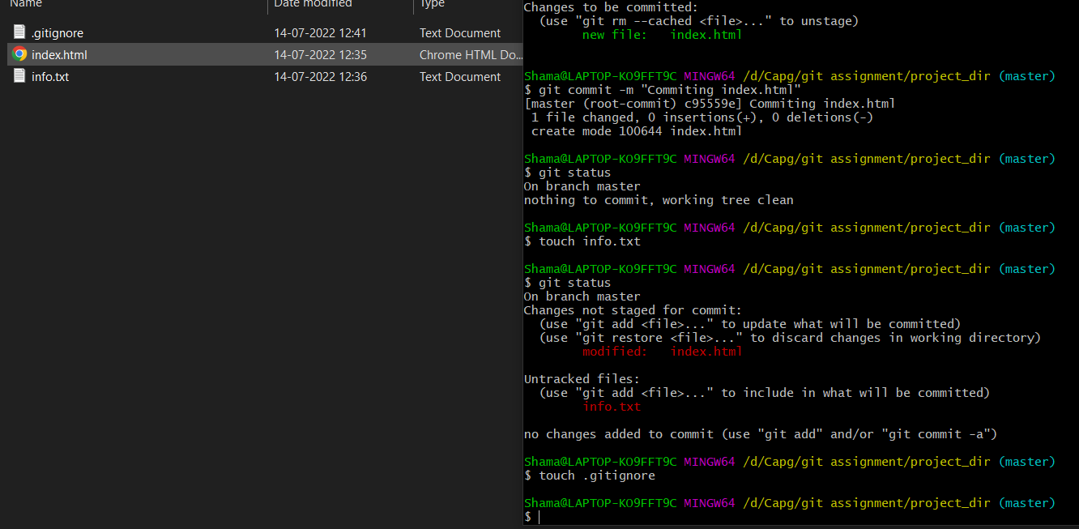

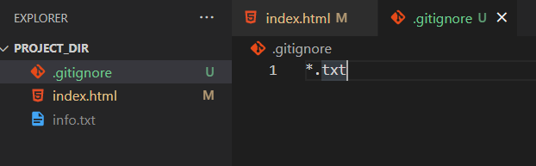

10. Again check the git status. You should find only gitignore as untracked file.

11. Stage and commit.

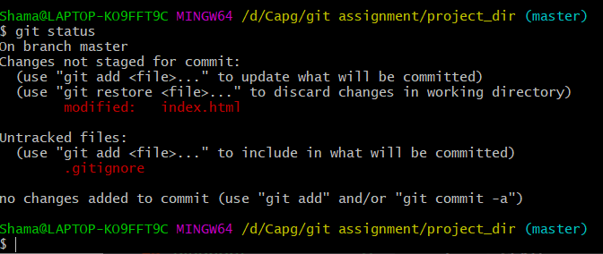

12. Log all your comments so far.

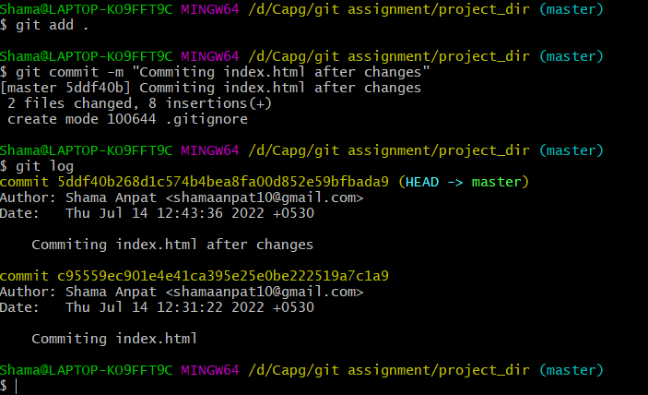

13. Make some changes in index.html

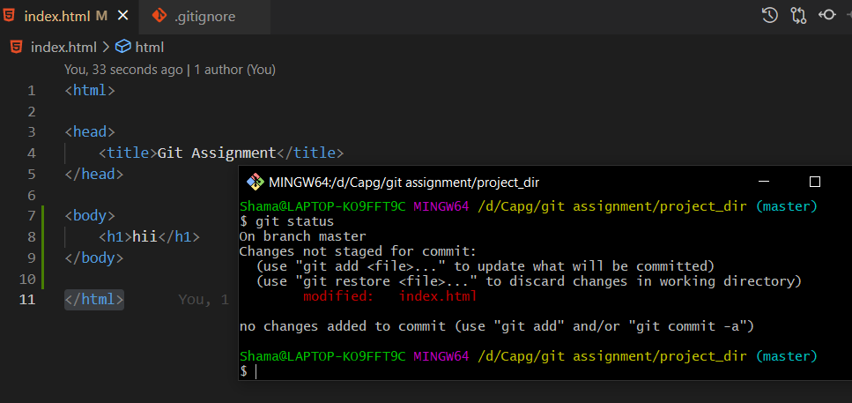

14. Revert the changes made in the previous step using git command.

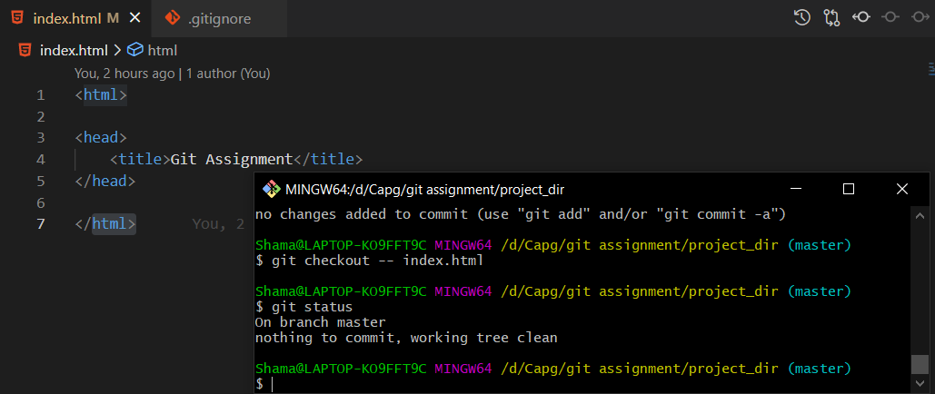

15. Again change index.html

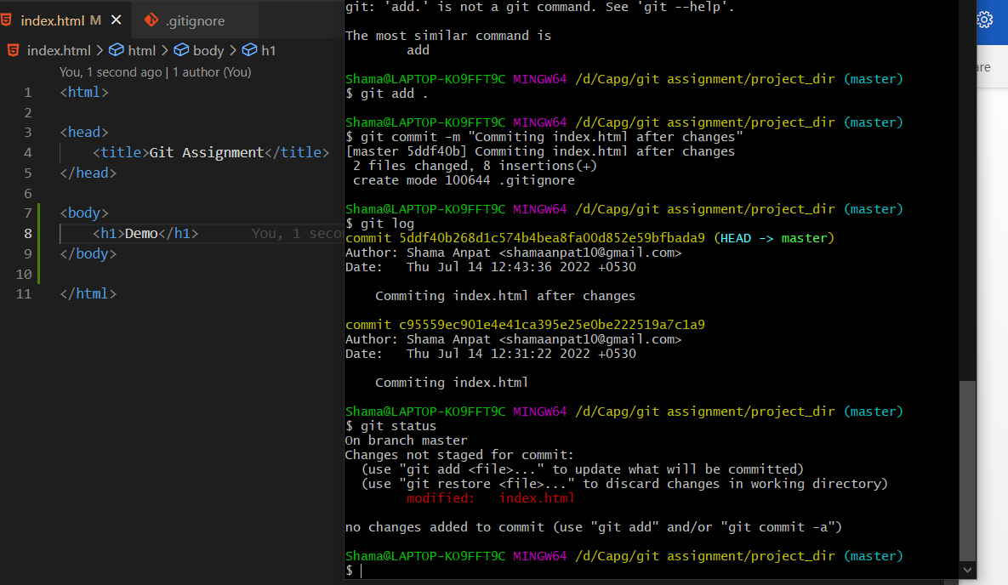

16. Stage index.html.

17. Revert back the last stage.

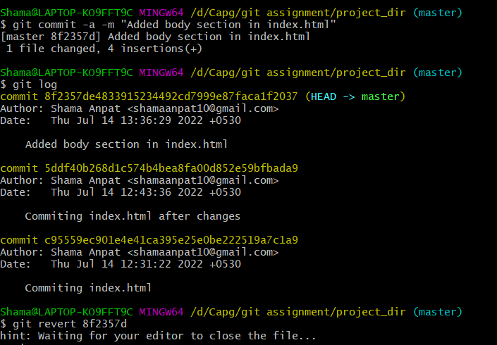

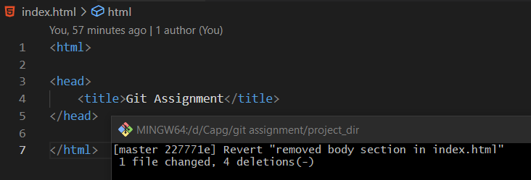

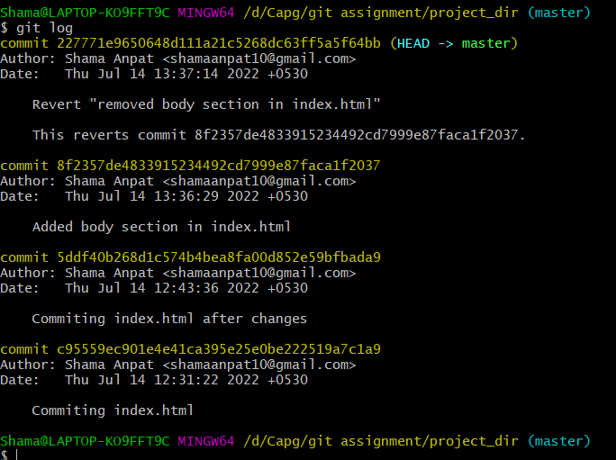

18. Rename ‘add’ command to ‘my_add’.

19. Using my_add command Stage index.html again & commit the changes.

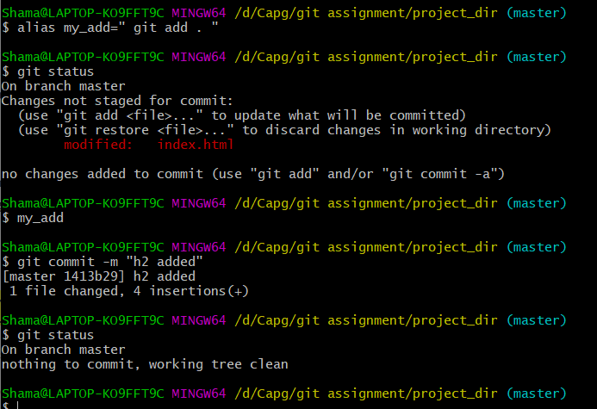

20.Revert the last commit

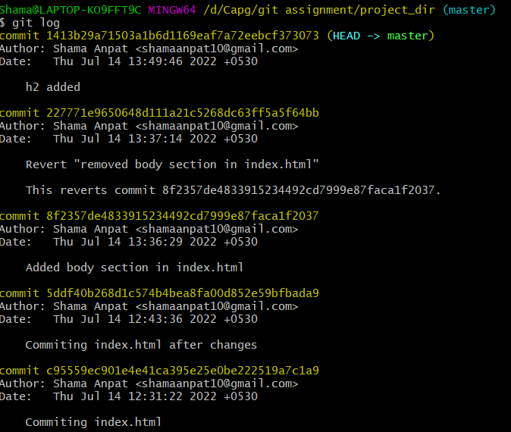

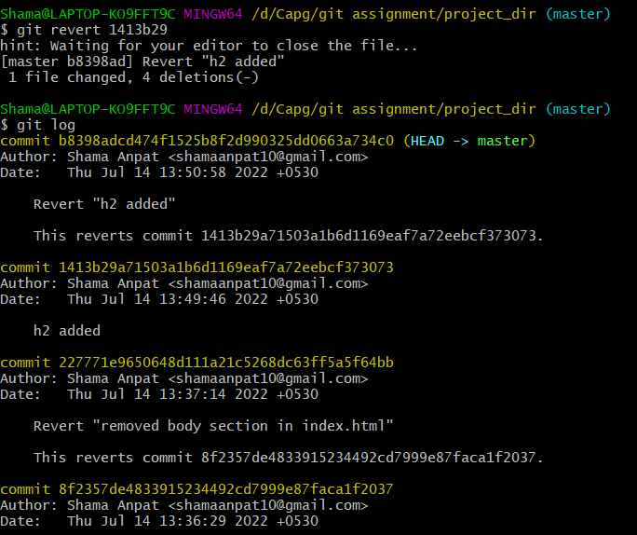

SECTION 1

22. Create an empty directory named Assignments and cd ‘Assignments’.

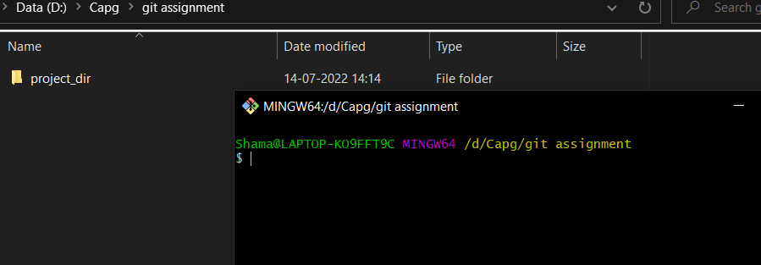

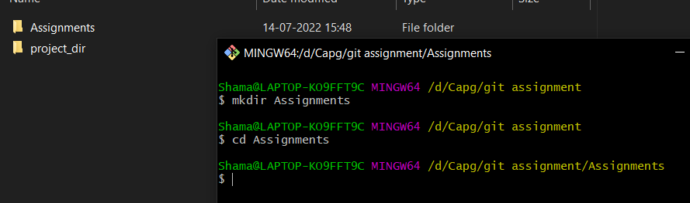

23. Create README.txt inside ‘Assignments’ and write few lines about the contents of ‘Assignments’ folder.

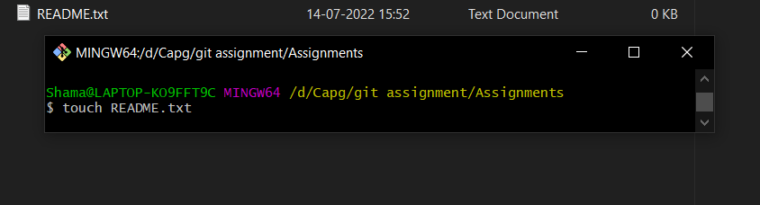

24. Commit README.txt

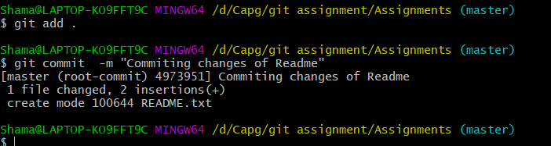

25. Now create a new branch ‘html-assignments’



26. Switch to ‘html-assignments’ branch

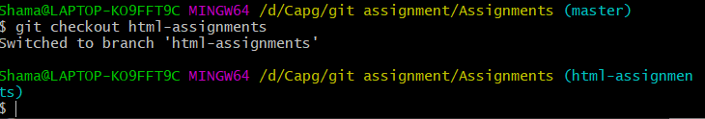

27. Copy all HTML assignments inside ‘Assignment’ folder

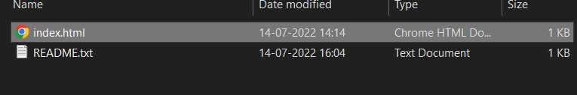

28. Commit HTML assignment into ‘html-assignments’ branch

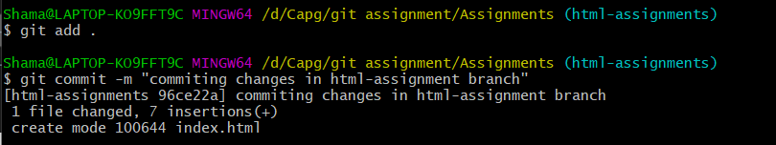

29.Make minor changes into few files belonging to ‘html-assignments’.

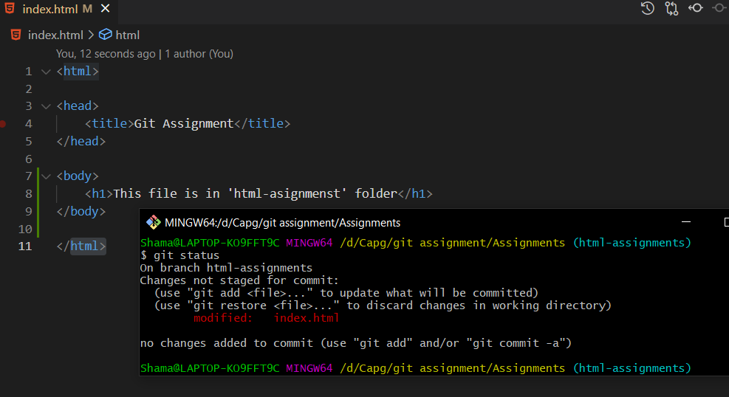

30.Commit those changes.

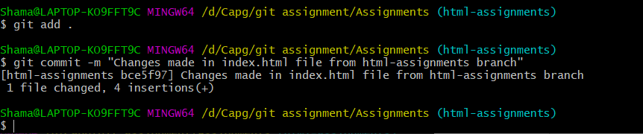

31.Switch to Master branch.

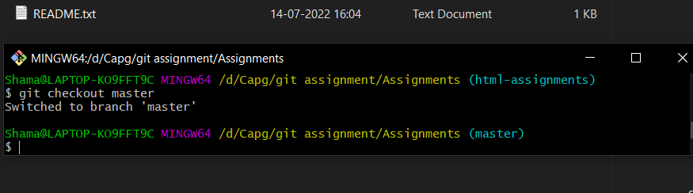

32.Make minor change in README.txt file & commit those in master branch.

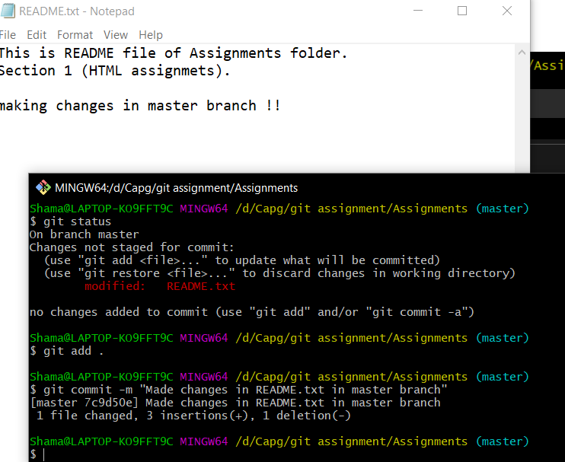

33. Again switch to ‘html-assignments’ branch.

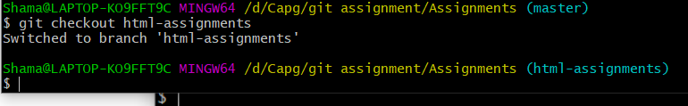

33. Make minor changes into few files belonging to ‘html-assignments’ branch.

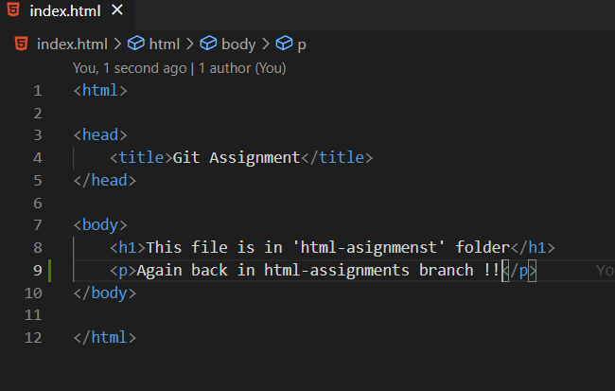

35. Commit those changes .

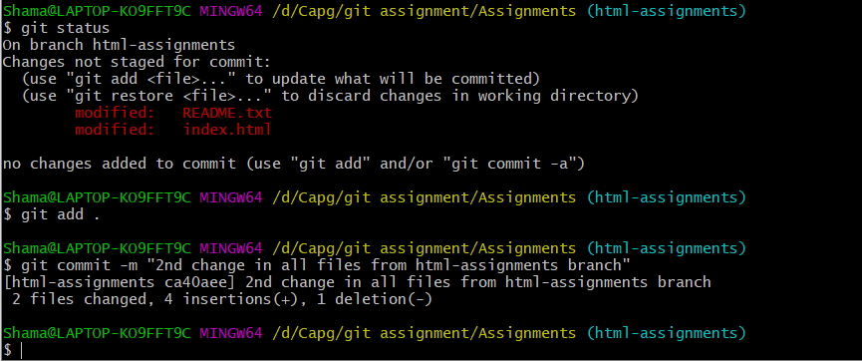

36. Switch to master.



37. Merger ‘html-assignments’ branch to master . Confirm all html assignments are shown in master.

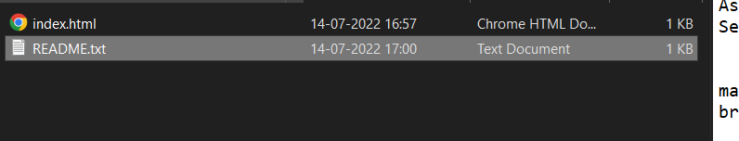

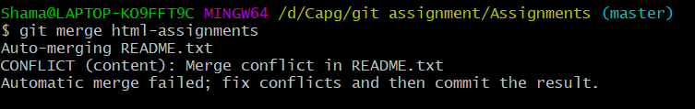

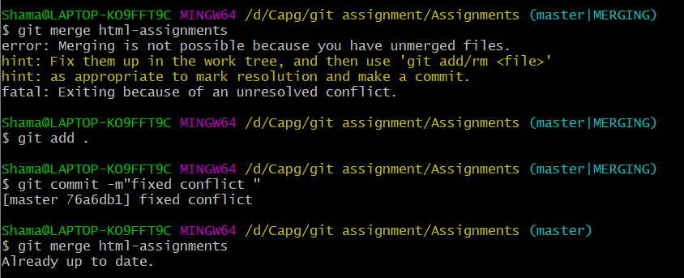

38. Finally Delete html-assignments branch.

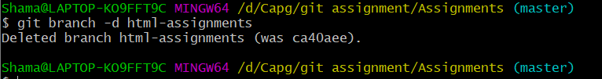

# GIT BRANCHING

SECTION 2

1. Create a new branch css-assignments



1. Switch to branch css-assignments

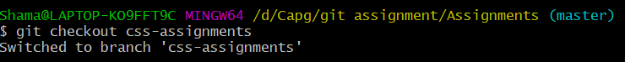

1. Copy all css files in Assignment folder.

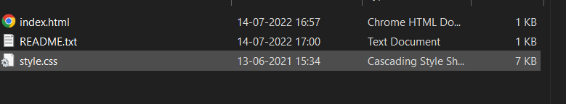

1. Commit all changes in css-assignments branch

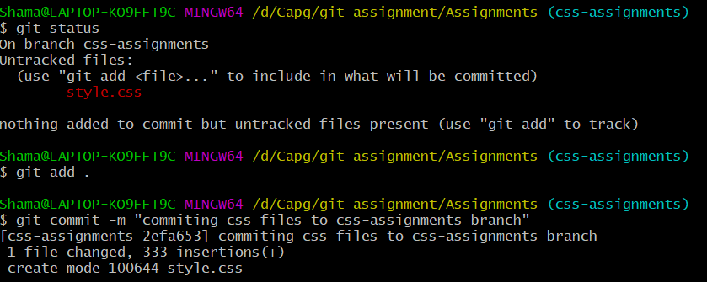

1. Make minor change in README.txt file on line 1 & commit those changes in css-assignments branch.

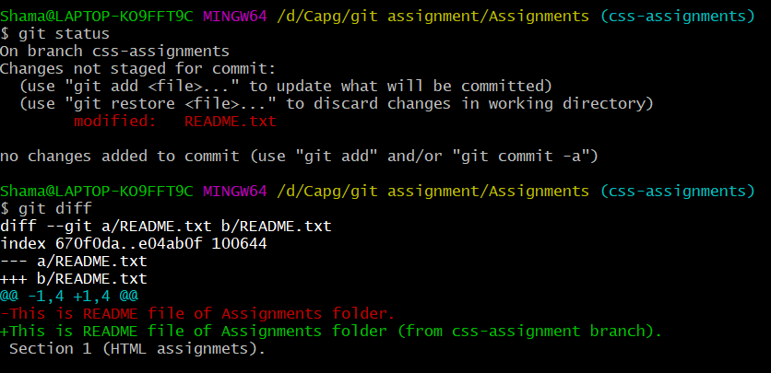

1. Commit those changes in css-assignments branch.

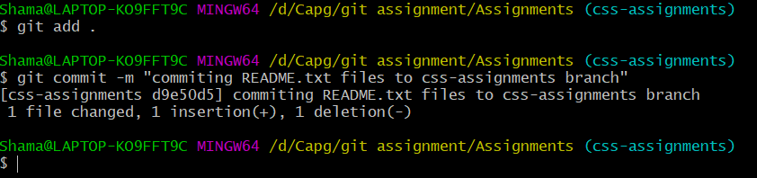

1. Switch to master branch.



1. Make minor changes in README.txt on line 3 and commit those changes to master branch.

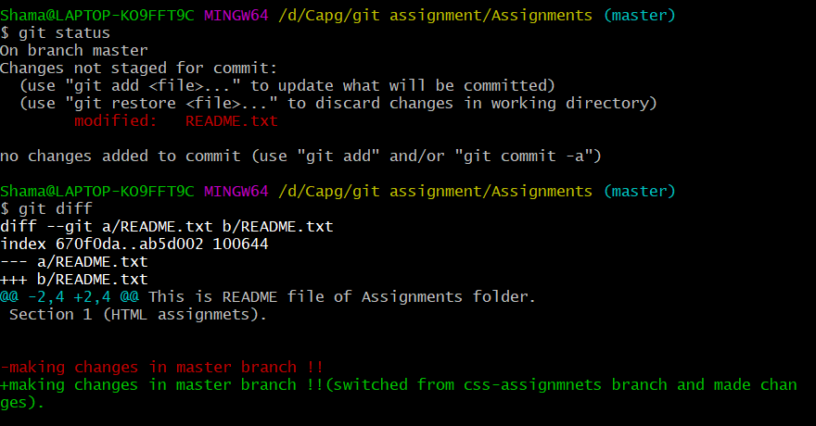

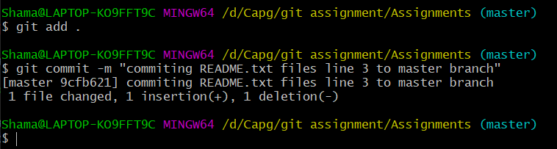

1. Again switch to css-assignments branch

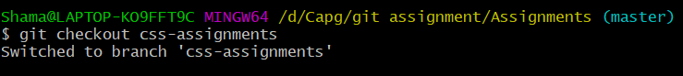

1. Make minor changes to file belonging to css-assignments branch.

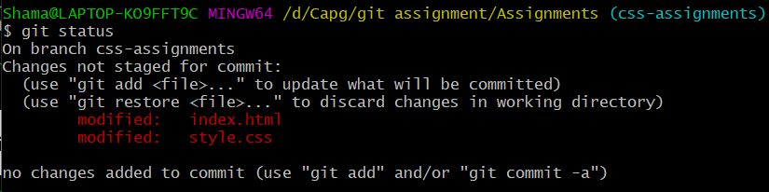

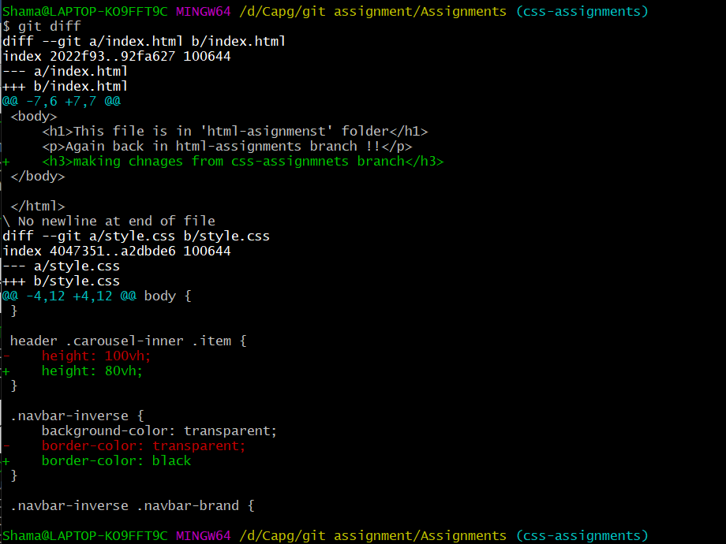

1. Commit those changes .

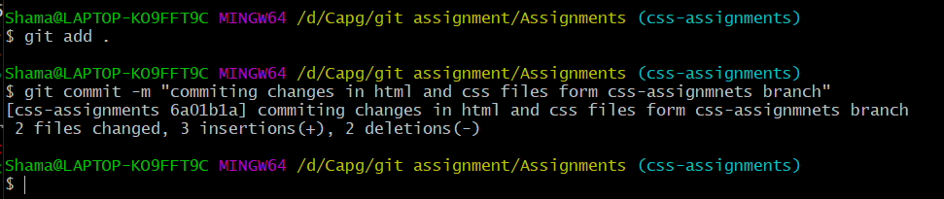

1. Switch to master.

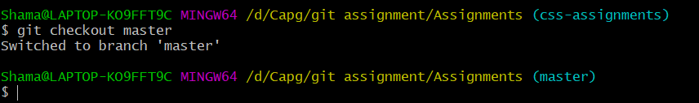

1. Merge css-assignments branch to master . make sure all css assignments are shown in master.



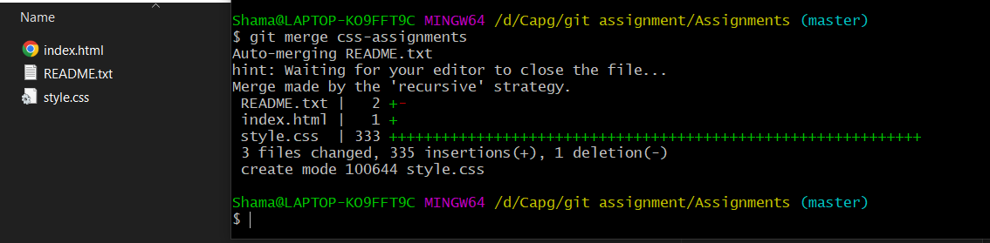

1. Finally delete css-assignments branch.

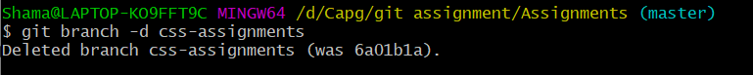

SECTION 3

1. Create a new branch ‘js-assignments’



1. Switch to ‘js-assignments’.



1. Copy all Javascript assignments inn ‘Assignments’ folder.

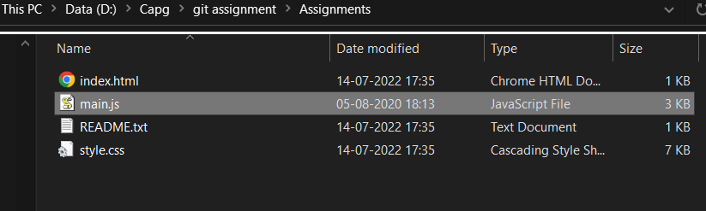

1. Commit javascript assignments to ‘js-assignments’ branch

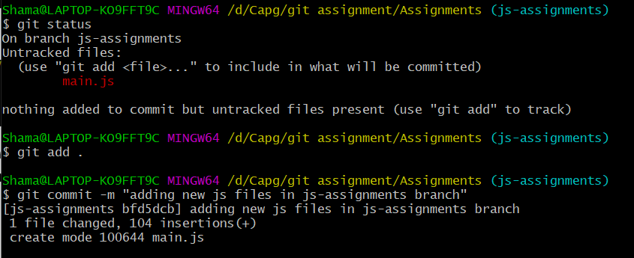

1. Make minor change in README.txt on line 1 in ‘js-assignments’ branch

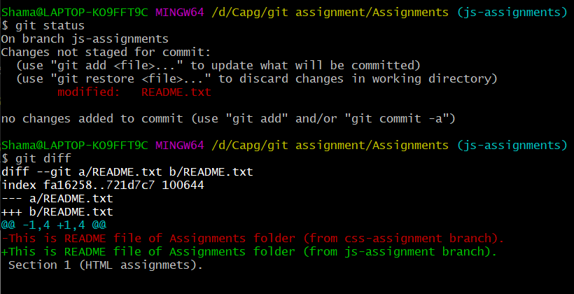

1. Commit those changed files

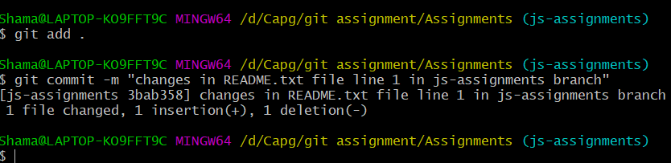

1. Switch to master branch
2. Make minor change in README.txt on line 1 in ‘master’ branch and commit those changes.

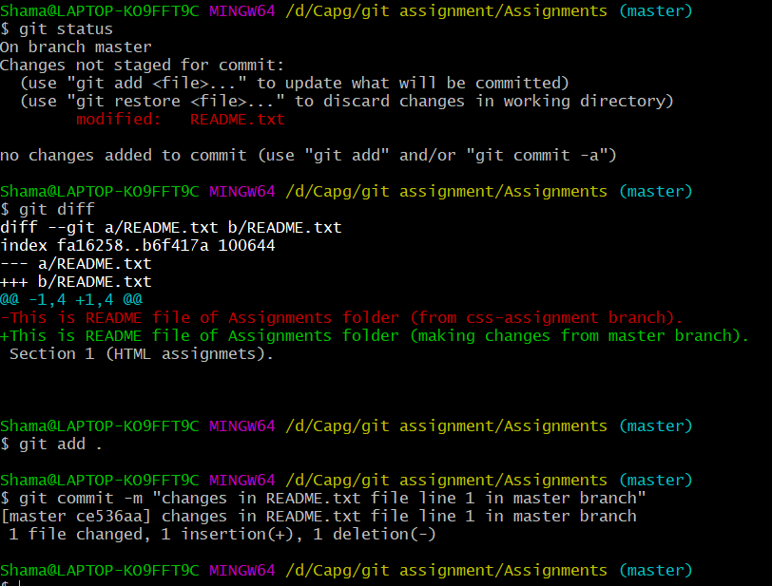

1. Again switch to ‘js-assignments’ branch

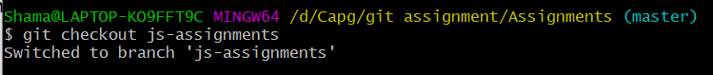

1. Make minor changes files belonging to ‘js-assignments’ branch

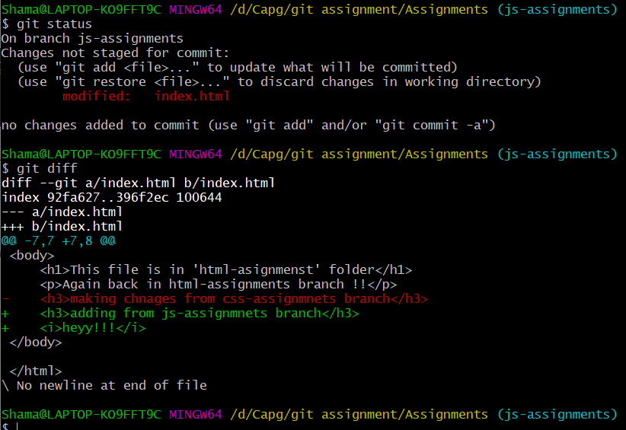

1. Commit those changes.

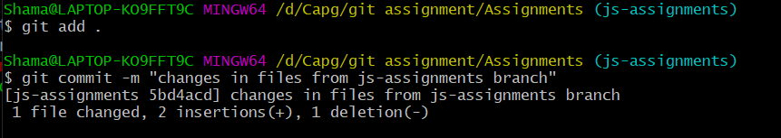

1. Merge ‘js-assignments’ branch to master branch. Confirm all javascript assignments are shown in master.

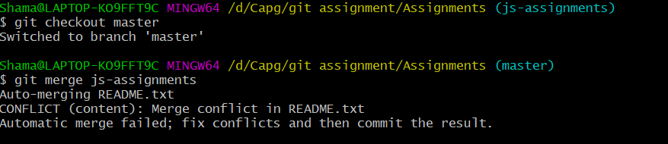

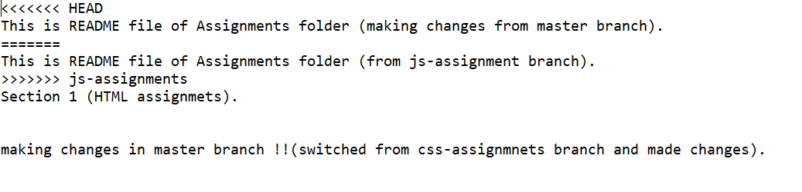

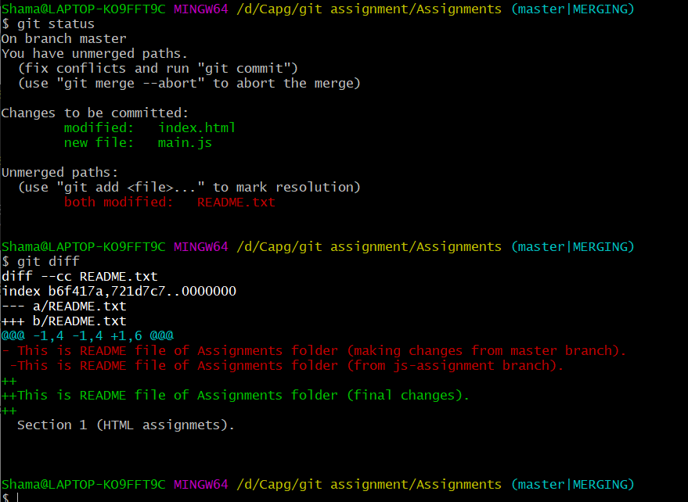

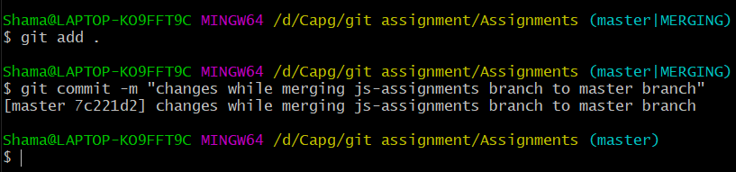

1. Finally delete ‘js-assignments’ branch.

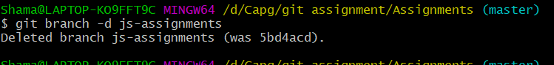

# GIT REMOTING

SECTION 3

1. Login into github account and creating repo named “freshersbatch-jul22”

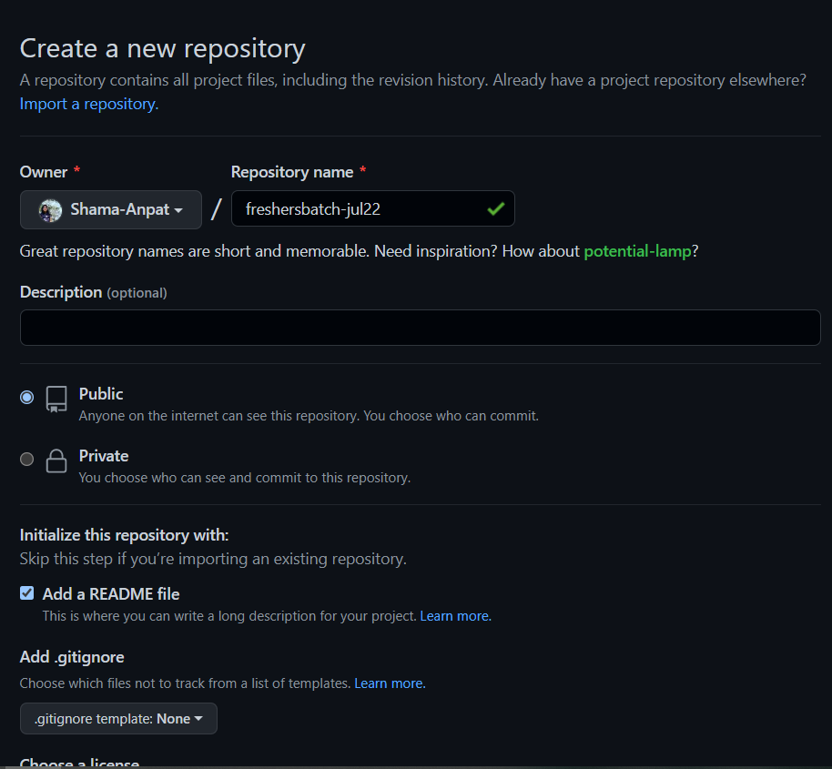

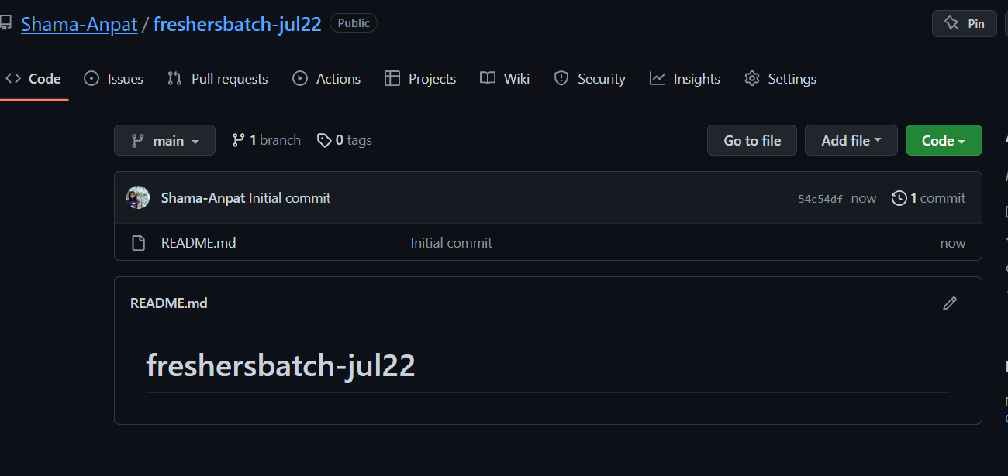

2. Create and push files to this repo under ‘Assignment’ repo

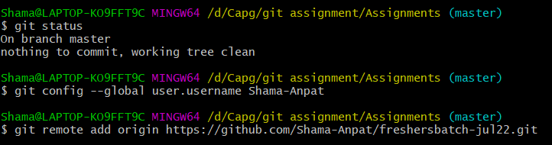

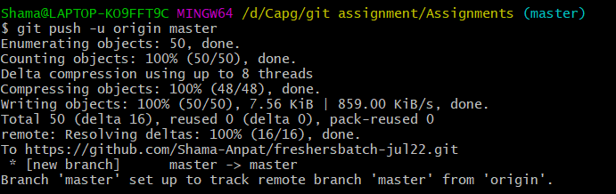

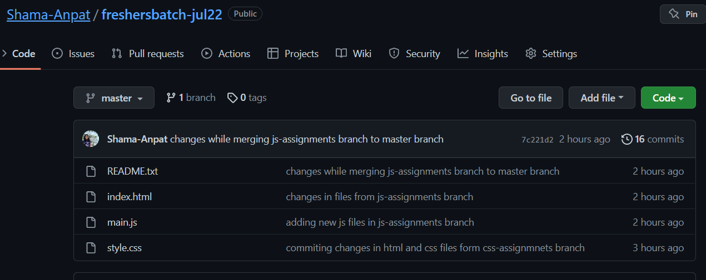

SECTION 4

1. Committing changes using vs code

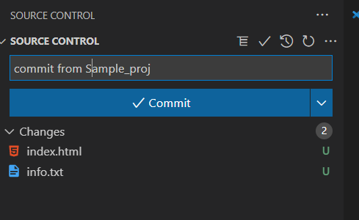

1. Add remote repo

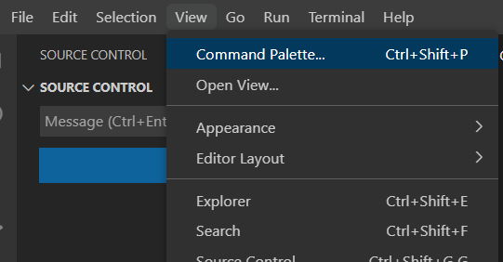

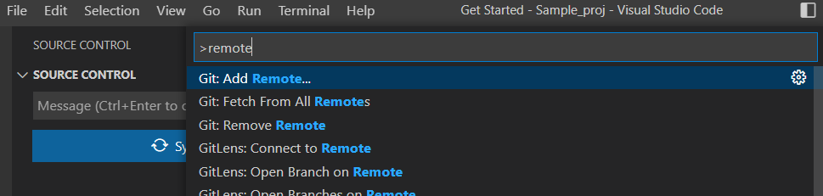

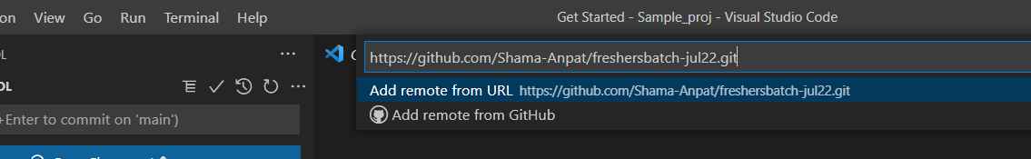

1. Push committed changes to git repo

